Free Dietitian Appointments
(Friday and Saturday morning)

What is a dietitian?
Dietitians are highly trained experts in food and nutrition. NZ Registered Dietitians study for five years at university and turn the latest nutrition science into simple advice that works for you. Dietitians also work with whānau and the wider community to deliver food and nutrition services.
Our approach
We understand that everyone is different. That is why our first session (up to one-hour long) is all about getting to know you and what you would like to focus on from a food and nutrition perspective. After the first session, we will work towards these goals in a comfortable and supportive environment.
We can help you with

- Healthy eating advice
- Weight/lifestyle management
- Pre and Type 2 Diabetes
- Heart Health
- Vegetarian/vegan
- Constipation or diarrhoea

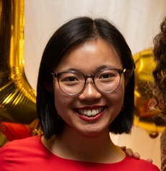
Meet our Dietitians
Steph Shen (NZRD, MHSc, BSc) – Friday morning
Kia ora! I am a Chinese Kiwi, born and raised in Tāmaki Makaurau (in Pakuranga). Food is important in social, cultural and spiritual ways. My approach is to explore these ideas with you and your whānau so that we can achieve long-term changes together.
In my spare time you can find me eating with friends and family, practising pilates, playing ultimate frisbee or disc golf!
Kate Harrington (NZRD, MHSc, BSc) – Saturday morning
Hello, I’m Kate! I’m passionate about helping you achieve positive health changes that are realistic for you and fit in with your lifestyle. I’d love to sit down and have a chat!
When not working, I enjoy spending time with friends and family. Otherwise, you’ll likely catch me at the cinema, playing tennis or cooking.

To book: Contact your Elstree GP or reception

